ADS Question Bank

UNIT-I |  | Marks
1 | Illustrate the creation of Priority Queue with one Example and it should contain Minimum 9 elements. | [10M]
2 | Demonstrate creation of Priority Queue on the following set of elements: 5, 8, 3, 9, 2, 10, 1, 40, 4, 2, 1. | [10M]
3 | What is Binomial Queue? Explain the operations on Binomial Queue with suitable examples. | [10M]
4 | Construct a Binomial Queue on the following list elements and explain each step with proper illustration: 39, 25, 69, 125, 364, 1, 78, 22, 99, 145, 33,102,100,300. | [10M]
5 | Distinguish Binomial Queue and Lazy Binomial Queue with proper examples. | [10M]
6 | Apply Percolate down strategy of Priority Queue on all the elements of following tree with tracing steps.  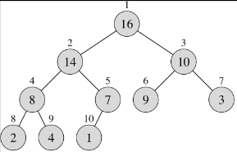 | [10M]
7(a) | Develop an algorithm to insert an element in to a heap. Explain with a suitable example | [5M]
(b) | Model the concept of priority queue with suitable example. | [5M]
8(a) | Apply heap sort for the data: 26,5,77,1,61,11,59,15,48,9 for sorting | [5M]
(b) | The elements 32, 15, 20, 30, 12, 25 and 16 are inserted one by one in the given order into a max-heap. What is the resultant Max-heap? | [5M]
9 | Distinguish Binomial Queue with Priority Queue with example. | [10M]
10 | Examine why heap implementation is better method for implementing Priority Queue than other methods. Discuss with suitable examples. | [10M]
UNIT-II |  | Marks
1 | Define Dictionary and Dictionary with duplicates. List the operation performed on dictionary. | [10M]
2 | Explain the division and MAD compression maps with an example each. | [10M]
3 | Explain chains hashing. Compare this with linear probing with suitable examples. State advantages and disadvantages of each method. | [10M]
4 | Explain the operations on Skip list with suitable examples and neat diagrams | [10M]
5 | Construct the open hash table using separate chaining and closed hash table using linear probing for the input: 20, 10, 5, 30, 40, 57, 3, 2,4,35,25,18,22,21 using the MAD method(a=7, b=13) | [10M]
6 | Organize the elements 13, 11, 4, 16, 19, 12, 5, 7, 3, 8, 18, 35, 15, 84, 16, 12 into hash table of size 17 by using double hashing method (use compression map of your own choice). | [10M]
7 | Organize the elements, 18, 35, 22, 15, 84, 32, 33, 24, 19 into hash table of size 11 by using linear probing method (use MAD compression map (a=13, b=11). Justify the load factor after last insertion. Describe how many buckets examined for an unsuccessful search. | [10M]
8 | Assume the following set of elements: 97, 40, 15, 22, 17, 89, 67, 99, 23, 34, how collision can be resolved using quadratic probing while inserting following keys in Hash table of size 10. | [10M]
9 | Construct hash table of size 11 by linear probing for the elements using MAD method (assume a=7, b=43): 45, 99,107, 44, 59, 22, 33, and 125. | [10M]
10 | Distinguish Primary clustering and Secondary clustering regarding hashing techniques with proper examples | [10M]

UNIT-III |  | Marks
1 | Demonstrate and explain how single and double rotations are performed while inserting a node into an AVL trees with suitable diagrams. | [10M]
2 | Explain splay tree rotations with an example each. Insert sequence of keys in splay tree : 9, 2, 90, 53, 4, 64, 95, 59,90,15 | [10M]
3(a) | Illustrate the properties of AVL tree? Write the procedure to search for an element of an AVL search tree | [5M]
(b) | Construct an AVL tree for alphabets in your name ( at least 12 characters) | [5M]
4 | Demonstrate and explain how rotations are performed for deleting a node from an AVL trees with suitable diagrams | [10M]
5 | Explain about the procedure to insert an element into an AVL tree with an example. | [10M]
6(a) | Build an AVL tree with the following values 20,10,5,30,40,57,3,2,4,35,25,18,22,21. | [5M]
(b) | Illustrate operations on Splay tree with example. | [5M]
7 | Delete element 50, 35 in the same sequence from following AVL tree. Trace the steps and discuss the cases matched.  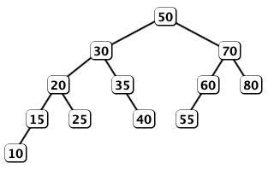 | [10M]
8(a) | How do we define the height of AVL Tree? Discuss about the balance factor associated with a node of an AVL tree. | [5M]
(b) | Explain LR, RL rotations on AVL tree with proper examples. | [5M]
9 | Describe the methods to represent an AVL tree, and Analyze the height of an AVL tree with an example. Discuss LL, RR rotations with examples. | [10M]
10 | What is splay tree and explain its role in searching. Delete element 10 and 15 from the following splay tree, Trace steps  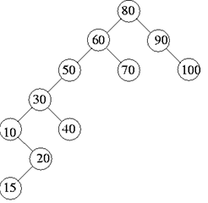 | [10M]

UNIT-IV |  | Marks
1(a) | Discuss Red-Black tree properties, | [5M]
(b) | List the insertion rules in red black tree with example? | [5M]
2 | State the properties of B-tree? Construct a B-tree of order 3 for the following set of elements: 45, 37, 05, 09, 06, 11, 18, 27, 2, 1, 7, 9, 10, 12, 5. | [10M]
3 | Given the following Red-Black tree, show each corresponding RB tree after deletion of 52 and 101 in this order. Explain the cases that matched. ( Note: 16, 76, 93 and 65 are red nodes)  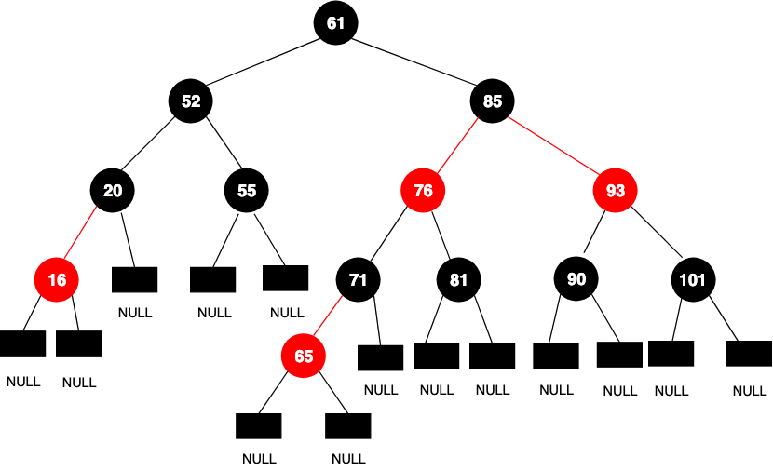 | [10M]
4 | Construct a Red-Black Tree for following set of elements: 23,4,33,7,24,9,10,11,13,38. Trace the steps for insertion. | [10M]
5 | Construct B-tree of order 5 for following elements: 10, 12, 1, 14, 6, 5, 8, 15, 3, 9, 7, 4, 11, 13 and 2. | [10M]
6 | Build a RB tree for the elements : 50, 20, 60, 90, 40, 100, 10, 12, 39, 99, and 2. | [10M]
7 | Classify different types of Balanced trees? Analyze the usage of balance parameter used in different types of trees? Use proper examples for analysis. | [10M]
8 | Classify different cases in Red-Black Tree deletion operation with an examples | [10M]
9 | Distinguish Red-Black trees with AVL trees. Use suitable examples | [10M]
9 | Consider following Red-Black tree ( Red nodes: 2,6,7,9)  - Insert elements: 0, 10. Trace the steps  - After inserting elements, delete elements: 4 and 6. Trace the steps.  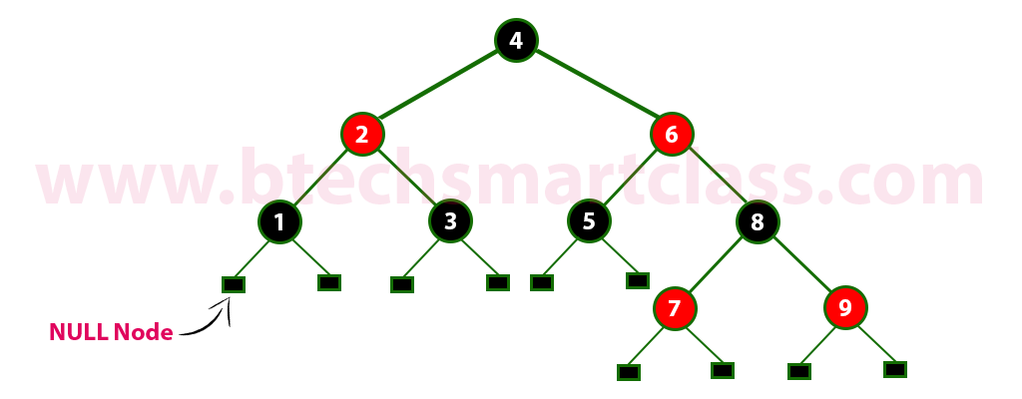 | [10M]

UNIT-V |  | Marks
1 | Explain Boyer-Moore Pattern matching algorithm with an example? State advantages and disadvantages | [10M]
2 | Explain Knuth-Morris-Pratt pattern matching algorithm with an example? State advantages and disadvantages | [10M]
3 | Distinguish KMP pattern matching algorithm with BMP pattern matching algorithm with an example. | [10M]
4 | Apply Brute force algorithm to search a pattern" CTGCCTAG" in the given text " CTCACTGCCTGCCTAIG". Trace the steps. | [10M]
5 | Apply Boyer Moore algorithm to search a pattern "ABCA” in the given text "ABCABCADABCCABCAB". Trace the steps | [10M]
6 | Apply Knuth Morris Pratt algorithm to search a pattern "ABABACA" in the given text "BACBDACBABABACAABCBABABACA". Trace the steps | [10M]
7 | Construct a Standard trie and Compact Standard trie for the string. Trace the steps and Compare both methods.  “SEE A LION? SELL THE STOCK!  SEE A BULL? BUY THE STOCK!  BID STOCK! BID STOCK!  BUY STOCK! SELL STOCK!  HEAR THE BELL? STOP! “ | [10M]
8 | Trace out the algorithm for Brute Force pattern matching, and discuss by considering the text string T[ ] : HARD WORK IS THE ONLY WAY TO REACH TARGET, and pattern P[ ] : REACH. Trace the steps and Analyze the algorithm. | [10M]
9 | Trace out the algorithm for BMP pattern matching, and discuss by considering the text string T[ ] : “INSTEAD OF WORRYING ABOUT WHAT YOU CANNOT CONTROL, SHIFT YOUR ENERGY TO WHAT YOU CAN CREATE.”, ancd pattern P[ ] CREATE. Trace the steps. | [10M]
10 | Trace out the algorithm for Knuth-Moriris-Pratt pattern matching, and discuss by considering the text string T[ ] : “DON'T BE PUSHED AROUND BY THE FEARS IN YOUR MIND”, and pattern P[ ] : MIND. Trace the steps | [10M]

UNIT-VI |  | Marks
1(a) | Explain about the special characters in files. | [5M]
(b) | Explain about Patricia tree with examples. | [5M]
2 | Explain about file processing operations with syntax and examples | [10M]
3 | Explain error handling during file I/O with syntax and suitable examples. | [10M]
4 | Illustrate various ways of constructing field structures and record structures with suitable examples. | [10M]
5 | Explain about the following  a) Opening files  b) Fixed length record  c) Program for display file contents on screen | [10M]
6 | Explain about the following  a) Reading file contents  b) Writing file contents  c) Special characters in files | [10M]
7 | Categorize different ways of writing into a file and explain the ways with proper programming examples. | [10M]
8 | Model and explain the structure of Indexed Sequential File with proper examples | [5M]
9 | Compare the sequential files and indexed sequential files. | [10M]
10 | What is a record? Contrast different ways in which records can be organized in a file with suitable examples? | [10M]

********

